

**Shri. Ramdeobaba College of Engineering and**

**Management, Nagpur (440013)**

(Autonomous Institute Affiliated to Rashtrasant Tukdoji Maharaj Nagpur University, Nagpur) 2022-2023

Department of Electronics Engineering

Deep Learning for Visual Recognition (ENTH52) Project Report

**Title: - Facemask detection using Convolutional neural network**

Submitted by:

|  |  |  |
| --- | --- | --- |
| Section | Roll no. | Name of the Student |
| B | 12 | Prajwal Shette |
| B | 55 | Vishal Yadav |

Under the guidance of: - Dr. Vikas Gupta

**ABSTRACT:**

In the recent times, the Coronaviruses that are a big family of different contagions have come veritably common, contagious, and dangerous to the whole humankind. It spreads mortal to mortal by exhaling the infection breath, which leaves driblets of the contagion on different shells which are also gobbled by another person and catches the infection too. So, it has come veritably important to cover ourselves and the people around us from this situation. We can take preventives similar as social distancing, washing hands every two hours, using sanitizer, maintaining social distance and the most important wearing a mask. Public use of wearing masks has come veritably common far and wide in the whole world now. From that the most affected and ruinous condition is of India due to its extreme population in small areas. This paper proposes a system to descry if the face mask is put on or not for services, or any other plant with a lot of people coming to work. We've used convolutional neural networks for the same. The model is trained on a real- world dataset and tested with live videotape streaming with a good delicacy. Further the delicacy of the model with different hyperactive parameters and multiple people at different distances and locales of the frame is done.

**INTRODUCTION:**

Public use of face masks has been common in China and other nations in the world since the morning of the new coronavirus complaint outbreak. We now know from recent studies that a significant portion of individualities with coronavirus lack symptoms( “ asymptomatic ”) and that indeed those who ultimately develop symptoms( “pre-symptomatic ”) can transmit the contagion to others before showing symptoms, according to the premonitory published by the health Centre. “ This means that the contagion can spread between people interacting in close propinquity, indeed if those people aren't flaunting symptoms ”. The recent information also gives a trace of a new strain of coronavirus, the mutant nimbus contagion which, in which the contagion has changed its structure and come mutant. The new strain isn't indeed suitable to descry using the RT- PCR test we use now. So, it's ineluctable for the people of an overpopulated country like India to wear masks and let the work goes on. nothing can keep an eye on whether every person coming into the workspace is wearing a mask or not. So the need for Face mask discovery arose. The model in this paper uses the Convolutional Neural Network. It's a deep neural network model used for assaying any visual imagery. It takes the image data as input, captures all the data, and sends the layers of neurons. It has a completely connected subcaste, which processes the final affair that represents the vaticination about the image. The Convolutional neural network model used, where is the successional Model CNN armature. successional model is a network model where each subcaste has exactly one input and affair and is piled together to form the entire network. Its depth wise divisible complication has two layers depth wise complication and point complication. It's grounded on an reversed residual structure where the residual connections are between the tailback

layers. The intermediate expansion subcaste uses featherlight depth wise complications to sludge features as source ofnon-linearity. The armature of successional Model contains the original completely convolution layers. The frame of Sequential Model which uses the model bandied in this paper. Further the different hyperactive parameters are tried for the model. The hyperactive parameters tried are learning rate, it's a tuning parameter that's used in optimization models which determines the step size of the model and helps to reduce the loss function. It's a veritably important hyperactive parameter as it results in either confluence or overshoots the model. The other hyperactive parameters used are batch size, ages etc.

**Related Work:**

They've proposed apre-trained MobileNet Model with a global pooling block for face mask discovery. The pre- set MobileNet Model takes a shadowing picture and creates amulti-dimensional element chart. The worldwide pooling block that has been used in the proposed model changes the element chart into an element vector of 64 highlights. At long last, the SoftMax subcaste performs paired order exercising the highlights. We've assessed our proposed model on two openly accessible datasets. Our proposed model has fulfilled 99 and 100 fineness on DS1 and DS2 independently. The worldwide pooling block that has been employed in the proposed model dodges overfitting the model. Further, the proposed model beats being models in the volume of boundaries just as preparing time. But this model can not descry face masks for multiple faces at a time. paper utilizes a complete and strong item position computation to naturally identify the appearances with curtains or without covers, making the pest avoidance work cleverer. They gathered a broad data set of 9886 filmland of individualities with and without face covers and physically named them, at that point usemulti-scale medication and picture mistake ways to ameliorate YOLOv3, an composition recognition computation, to accordingly distinguish whether a face is wearing a robe. Our analysis results show that the mean Average Precision( chart) of the bettered YOLOv3 computation model came to86.3. This work can viably and naturally distinguish whether individualities are wearing curtains, which decreases the pressing factor of conveying HR for checking covers openly puts and has high functional operation regard.

**Dataset and Features:**

The model proposed then's designed and model using python libraries videlicet Tensorflow, Keras and OpenCV. The model we used is the successional Model using convolutional neural networks. The system of using a successional Model In Keras, a successional model can be erected by using the successional() class. Then, we successionally add layers to the model using the add() system. Somepre-trained models to train your present model and get the vaticination which saves time and makes using training the different models easy. We tune the model with the hyperactive parameters learning rate, number of ages and batch size. The model is trained with a dataset of images with two classes, with mask and without mask. The dataset has 690 images with mask class and 686 images without mask class.( i) Training the model with the taken dataset.( ii) Planting the model In the paper we've developed a model using the over mentioned libraries. We've tested the model for different conditions with different hyperactive parameters, for which the results are mentioned in the coming section. First, we feed the dataset in the model, run the training program, which trains the model on the given dataset. also we run the discovery program, which turns on the videotape sluice, captures the frames continuously from the videotape sluice with an anchor box using an object discovery process. This is passed through the successional model using CNN layers which classifies the image switcher withoutmask.However, agree anchor box is displayed and red if not wearing a mask with the delicacy for the same tagged on the anchor box, If the person is wearing a mask. The inflow of the Face Mask Detection model used in this paper. The face mask recognition system uses technology to descry the person with or without a mask. It can relate to any surveillance system installed at your premise. The authorities or admin can check the person through the system to confirm their identity. The system sends an alert communication to the authorized person if someone has entered the demesne without a face mask. The delicacy rate of detecting a person with a face mask is99.35 depending on the digital capabilities. The data has been transferred and stored automatically in the system to enable reports whenever you want.

**RESULTS:**

We have tested the model for different scenarios, below mentioned is the table with the results of those scenarios with number of epochs 25, constant for all the three situations. We have used Average Pooling for capturing smooth images. shows the results of comparison of different hyper parameters and situations. According to the above results the first model is the best compared to all the models. The plot of the best model from our research is shown below. It shows the plot for training loss, validation loss, training accuracy and validation accuracy for Number of epochs versus loss or accuracy. It is evident from the plot that as the number of epochs increases the training and validation accuracy increases and the training and validation accuracy decreases. And the validation accuracy is higher than the training accuracy which proves that the model is not suffering through overfitting. shows the plot for number of epochs versus loss or accuracy.

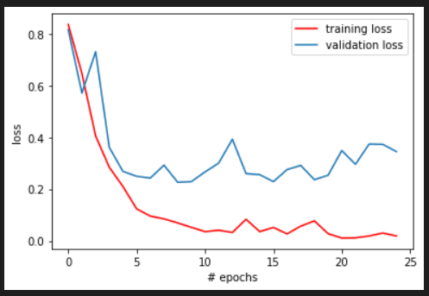**Training Loss and Validation Loss:**

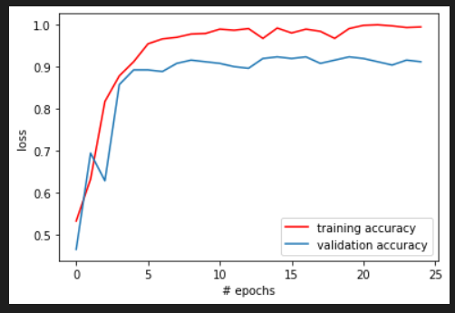**Training Accuracy and Validation Accuracy:**

**CONCLUSION:**

To moderate the spread of the COVID-19 pandemic, measures should be taken. We have demonstrated facemask detectors using Convolutional Neural Network And move learning techniques by the development of face mask detection, we can detect if the person is wearing a face mask and allow their entry would be of great help to the society. The accuracy of the model will be achieved, and the optimization of the model is a continuous process and so we are building a highly accurate solution. We can prevent peoples from Virus Transmission through this System.

**REFERENCE:**

1) A. G. Howard, M. Zhu, B. Chen et al., “Mobilenets:efficient convolutional neural networks for mobilevisionapplications,” 2017, <https://arxiv.org/abs/1704.04861>.

2) I. B. Venkateswarlu, J. Kakarla and S. Prakash, "Facemask detection using MobileNet and Global PoolingBlock," 4 2020 IEEE 4th Conference on Information & Communication Technology (CICT), 2020, pp. 1-5, doi: 10.1109/CICT51604.2020.9312083.

3) M. S. Ejaz and M. R. Islam, "Masked Face Recognition Using Convolutional Neural Network," 2019 International Conference on Sustainable Technologies for Industry 4.0 (STI), 2019, pp. 1-6, doi: 10.1109/STI47673.2019.9068044.